**DAILY ONLINE ACTIVITIES SUMMARY**

|  |  |  |  |  |  |  |  |  |
| --- | --- | --- | --- | --- | --- | --- | --- | --- |
| **Date:** | **06/06/2020** | | | | | **Name:** | **NAIPUNYA VINOD NAIK** | |
| **Sem & Sec** | **IV SEM & A SECTION** | | | | | **USN:** | **4AL18CS050** | |
| **Online Test Summary** | | | | | | | | |
| **Subject** | | **DATA COMMUNICATION** | | | | | | |
| **Max. Marks** | | **30** | | **Score** | | | **28** | |
| **Certification Course Summary** | | | | | | | | |
| **Course** | **INTRODUCTION TO DIGITAL MARKETING** | | | | | | | |
| **Certificate Provider** | | | **GOOGLE** | | **Duration** | | | **40 HRS** |
| **Coding Challenges** | | | | | | | | |
| **Problem Statement: 1) Write a Java program to sort an array in Ascending Order.**  **2)**[Write a program in C to rotate an array by N positions.](https://github.com/orgs/alvas-education-foundation/teams/2nd-year/discussions/103)  3) Write a Java Program to find the second-highest number in an array. | | | | | | | | |
| **Status: EXECUTED** | | | | | | | | |
| **Uploaded the report in Github** | | | | | **YES** | | | |
| **If yes Repository name** | | | | | <https://github.com/naipunya-naik/lockdown-coding/blob/master/JAVA%20CODING/sort_06-05-2020.java>  <https://github.com/naipunya-naik/lockdown-coding/blob/master/JAVA%20CODING/SecondHighest_06-04-2020.java>  <https://github.com/naipunya-naik/lockdown-coding/blob/master/C%20CODING/rotate%20array_06-04-2020.c> | | | |
| **Uploaded the report in slack** | | | | | **YES** | | | |

Online Test Details: (Attach the snapshot and briefly write the report for the same).

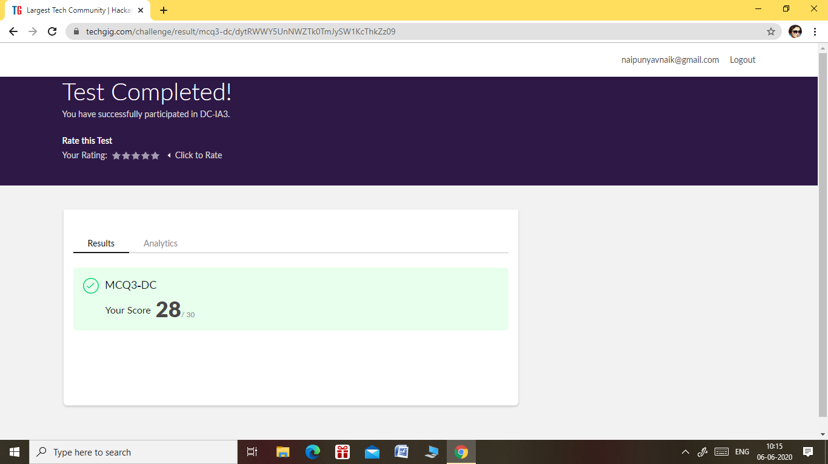

THE 3RD I.A TEST OF SUBJECT DATA COMMUNICATION WAS CONDUCTED ON 06 JUNE 2020.

* SUBJECT:- DATA COMMUNICATION
* SYLLABUS :- MODULE 5
* START TIME:- 9.30 AM
* END TIME:- 10.15 AM
* DURATION:- 45 MIN
* NO. OF QUESTIONS:- 30
* EACH QUESTION CARRIED 1 MARK

Certification Course Details: (Attach the snapshot and briefly write the report for the same).

CERTIFICATION COURSE NAME:- INTRODUCTION TO DIGITAL MARKETING

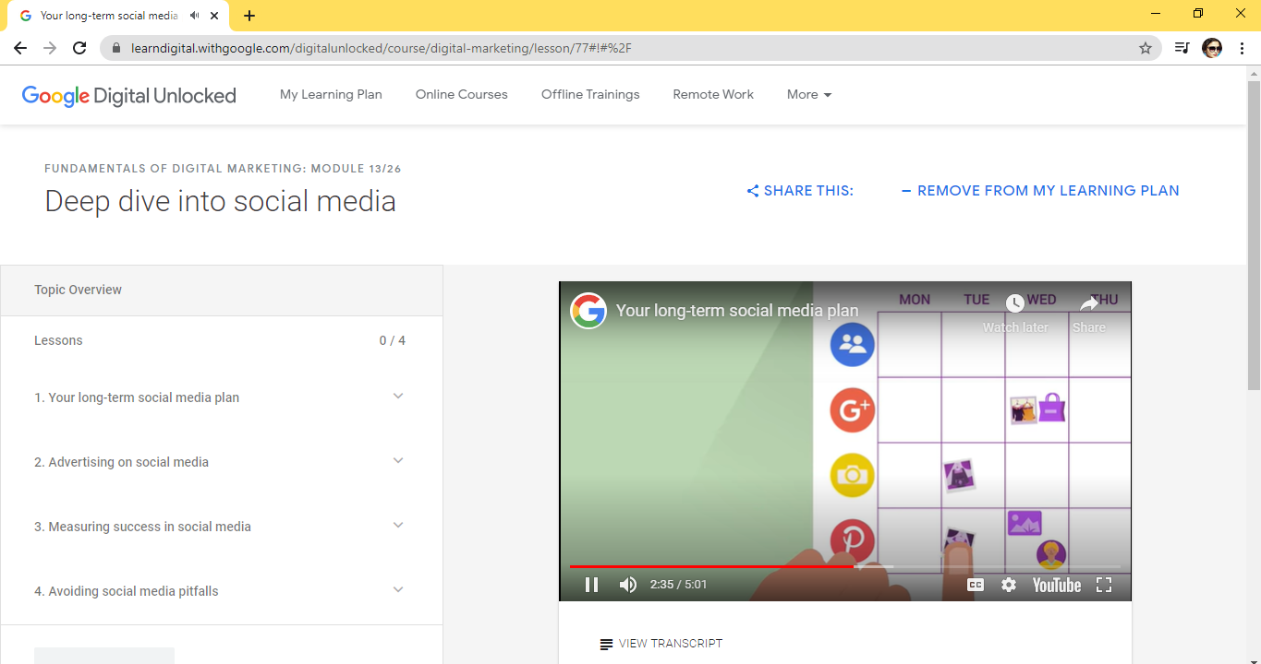

TOPICS LEART ON 06 JUNE 2020

* Lessons
* 1. Your long-term social media plan
* 2. Advertising on social media
* 3. Measuring success in social media
* 4. Avoiding social media pitfalls

Coding Challenges Details: (Attach the snapshot and briefly write the report for the same).

PROBLEM STATEMENT 1:- **Write a Java program to sort an array in Ascending Order.**

Given an array A of size N containing 0s, 1s, and 2s; you need to sort the array in ascending order.  
Input:  
The first line contains an integer 'T' denoting the total number of test cases. Then T testcases follow. Each testcases contains two lines of input. The first line denotes the size of the array N. The second lines contains the elements of the array A separated by spaces.

Output:  
For each testcase, print the sorted array.

Constraints:  
1 <= T <= 500  
1 <= N <= 106  
0 <= Ai <= 2

Example:  
Input :  
2  
5  
0 2 1 2 0  
3  
0 1 0

Output:  
0 0 1 2 2  
0 0 1

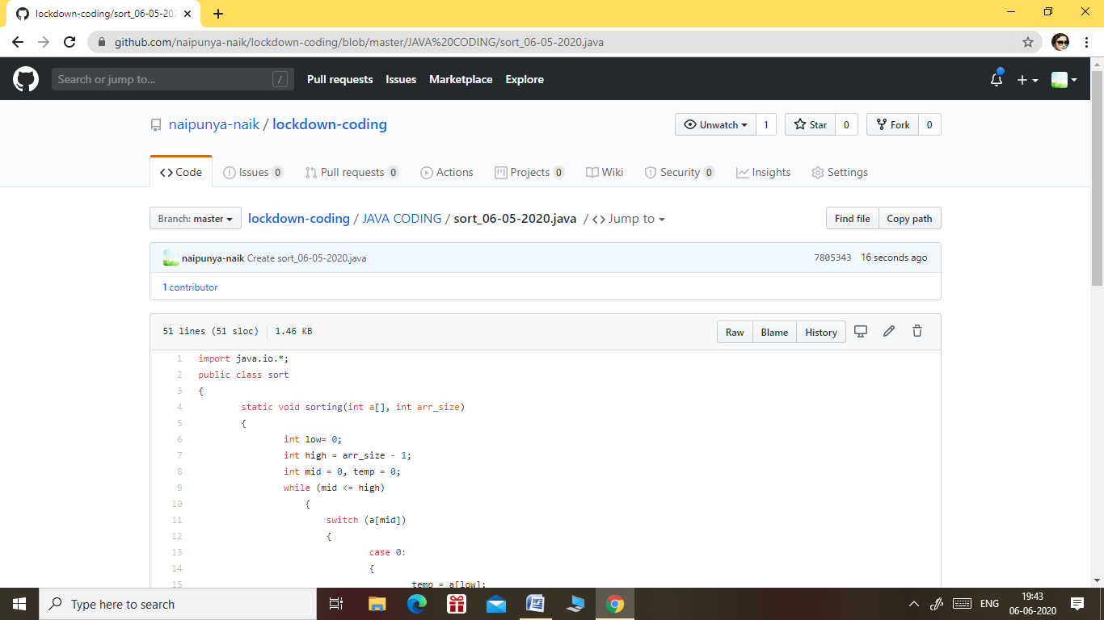

GITHUB REPOSITORY LINK:-

<https://github.com/naipunya-naik/lockdown-coding/blob/master/JAVA%20CODING/sort_06-05-2020.java>

PROBLEM STATEMENT 2:- [Write a program in C to rotate an array by N positions.](https://github.com/orgs/alvas-education-foundation/teams/2nd-year/discussions/103)

**Expected Output :**  
**The given array is :** 0 3 6 9 12 14 18 20 22 25 27  
Enter the Position N from where you want to rotate: 4  
From 4th position the values of the array are : 12 14 18 20 22 25 27  
Before 4th position the values of the array are : 0 3 6 9  
After rotating from 4th position the array is:  
12 14 18 20 22 25 27 0 3 6 9

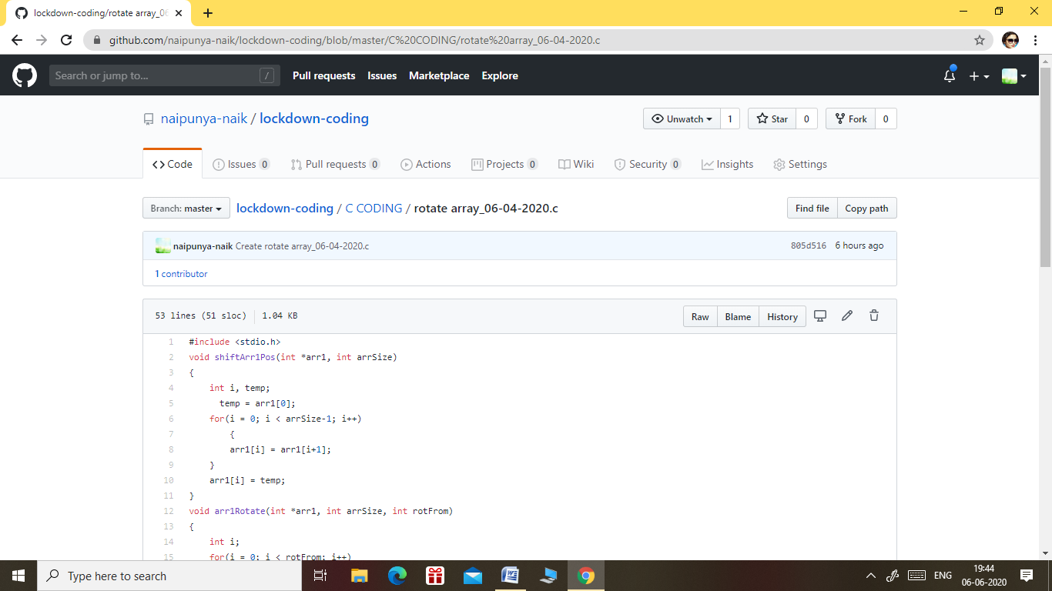

GITHUB REPOSITORY LINK:-

<https://github.com/naipunya-naik/lockdown-coding/blob/master/C%20CODING/rotate%20array_06-04-2020.c>

PROBLEM STATEMENT 3:- Write a Java Program to find the second-highest number in an array.

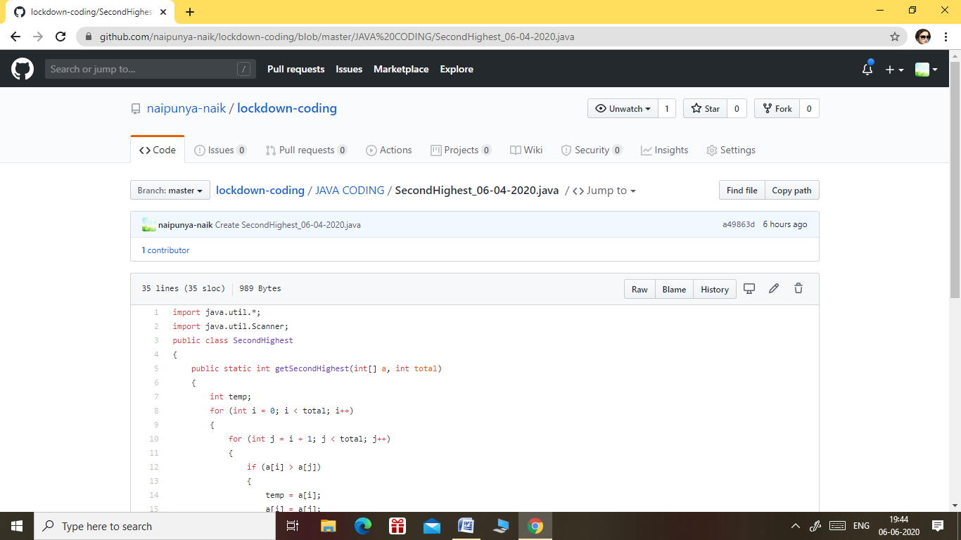

GITHUB REPOSITORY LINK:-

<https://github.com/naipunya-naik/lockdown-coding/blob/master/JAVA%20CODING/SecondHighest_06-04-2020.java>